# **Use Case Diagram**

# 

# **Domain Model**

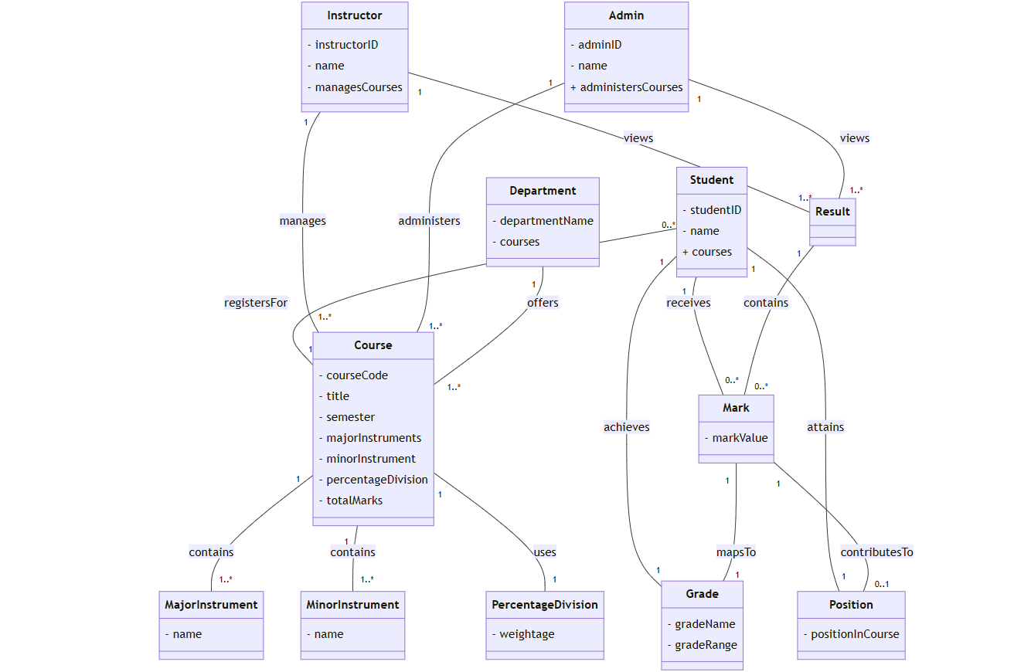

# **System Sequence Diagrams (View Result)**

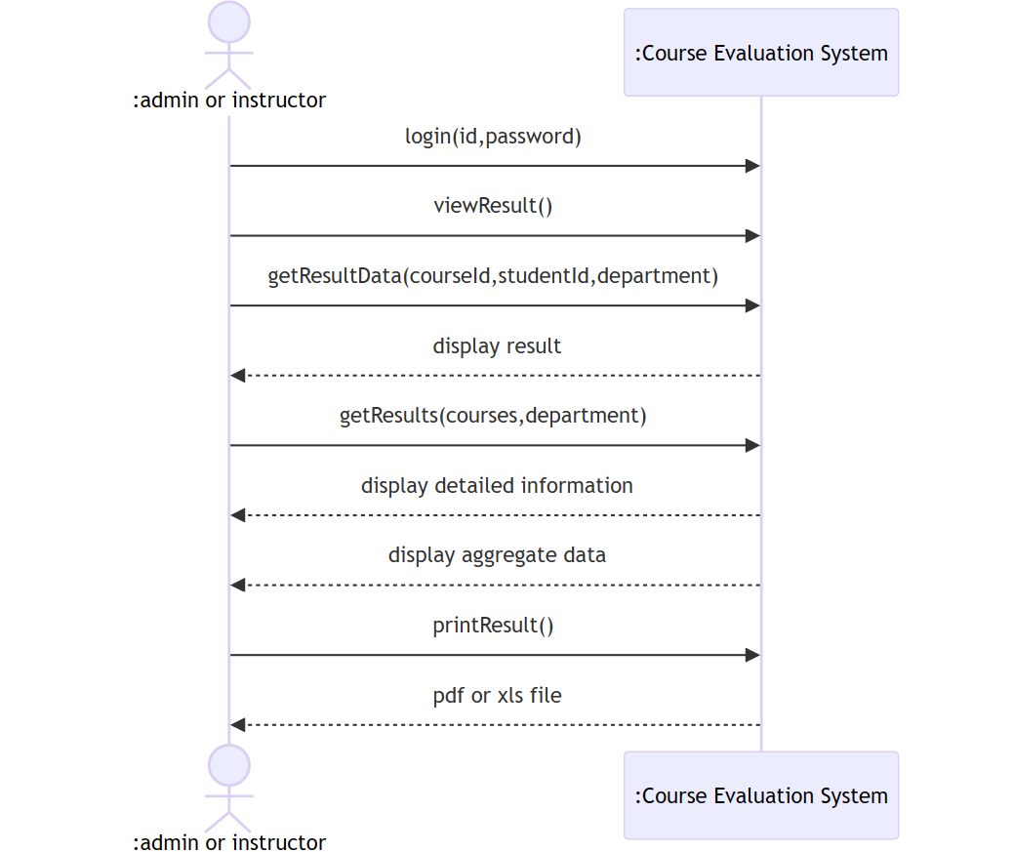

# 

# **System Sequence Diagrams (Major Instruments)**

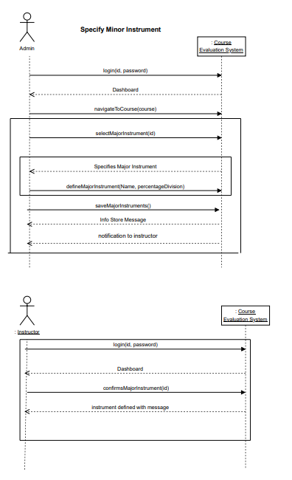

# **System Sequence Diagrams (Minor Instruments)**

